1. What will happen if you run this command?

docker run hello-world

1. How will you rectify the below error?

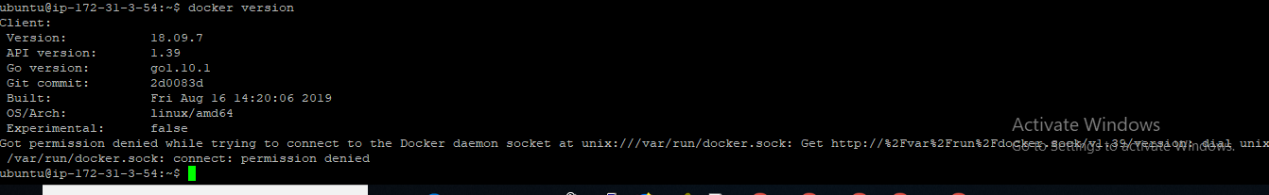

1. Can you run this command?

docker run busybox

What happened ? Is the image downloaded? What is this busybox means? Can you google?

1. Now run this command

docker run busybox echo “hello from Sameer”

What happened? How is is accepting the echo command here? Can you inspect the image and see whether you have anything under CMD or ENTRYP0INT ?

1. What does this command does?

docker rm $(docker ps -a -q -f status=exited)

1. What does this command does?

docker container prune

Is there any relationship between this command and the previous command? Are both the same?

1. Let’s try this.

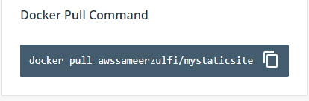

After this, Can you please check how many layers have been formed with the images?

And what is the instruction given under CMD? Where will you find that instruction file inside the Container?

And what are the ports exposed for this image?

And what is the size of this image?

Can you please run the below command and find out which port it has been mapped?

docker run –d –p –name staticsite awssameerzulfi/mystaticsite

Find out the host port which the above container is mapped and try to browse in your browser using aws instance publicip:port#

Now, Let’s map the port exclusively and try the below command

docker run -p 8888:80 awssameerzulfi/mystaticsite

Try to access the publicip:8888

So what’s the difference between the earlier command with –P(Capital P) and this command with –p (small p)

1. Let’s build an image

Please Create a Dockerfile with the below content

FROM ubuntu:latest

MAINTAINER sameer@example.com

RUN apt-get update && apt-get install -y apache2

COPY . /var/www/html

EXPOSE 80

CMD ["apache2ctl", "-D", "FOREGROUND"]

Build an image and run the container. Try to access it using the publicipofawsinstance:port# in your browser. If you are able to see the page. We are good.

Now try to delete the CMD line and build an image again. Run the container. See what happens when you try to access the site.

1. Now you must have already built some images as per my earlier 8th question.

Let’s try to push it to your dockerhub site.

Type this command “docker login”

It will ask you to enter your dockerhub userid and the password.

Once it’s done, please use the below command

docker push yourdockerhubuserid/reponame:tagname

For ex : docker push awssameerzulfi/mysite:v1

After it’s pushed, check whether you are able to see the same in your dockerhub site.

1. What this command does ?

FROM nginx

COPY html /usr/share/nginx/html

1. What is the difference between these two commands ?

docker run --name foo -d -p 8080:80 mynginx

docker run --name foo -d -P mynginx

1. Can you pull a Jenkins Image?
2. What is “docker history imageid” will do ?
3. What is “docker stats containerid” will do ?
4. What will the below Dockerfile do?

FROM ubuntu

MAINTAINER demousr@gmail.com

RUN apt-get update

RUN apt-get install –y nginx

CMD [“echo”,”Image created”]

1. Now, you have mistakenly tagged an image as V1, but it’s supposed to be V2. How can that be done?
2. Pull the Jenkins image and run it as Container, try to access the Jenkins page using the port. Once you get the home page of Jenkins, it will tell you to copy and paste the password from one location. Find it out.